Name Date

Quiz

For use after Section 5.4

Chapter

5

Use the graph to solve the system of linear equations. Check your solution.

1. 



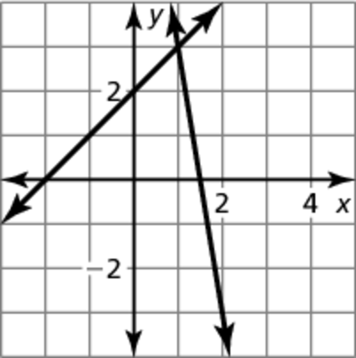

2. Solve the system of linear equations by graphing.

y= -x +4

y=2x -8

Solve the system of linear equations by substitution. Check your solution.

3. -5x +3y = 51 4. x + 4y = 17

y = 10x – 8 y = x - 2

Solve the system of linear equations by elimination. Check your solution.

5.  6. 5x + 6y = 50

 x - 6y = -26

Solve the system of linear equations. (choose any method)

7.  8. y = -6x -8 9. x + y = 3

 y = 6x + 8 2x + 2y = 6

Graph the system of linear inequalities.

10. 